1. Find the Eno, Ename of the employee whose salary is greater than 4000.
2. Combining Conditions and Boolean Operators

Find the Eno, Ename, Salary of the employee whose salary is greater than 5000 and job status is professor.

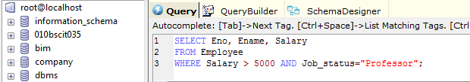

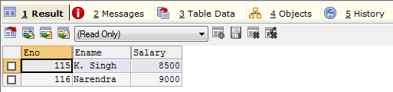

1. Removing Duplicates

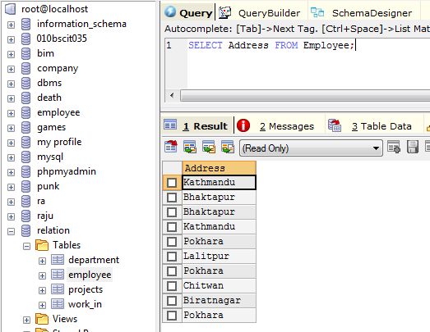

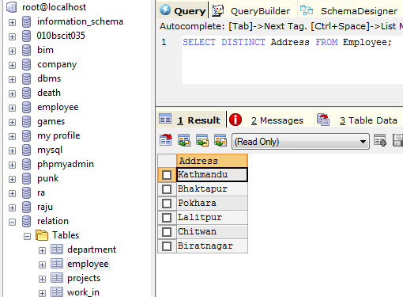

1. Find the Eno, Ename, Salary of the employees whose department number is 20 or job status is resource fellow.

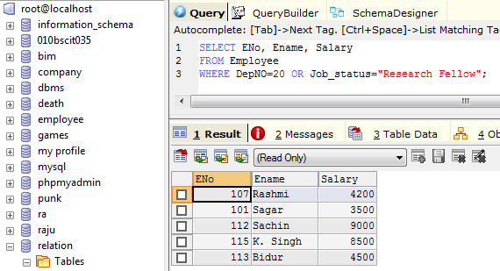

1. Find the Eno, Ename, Age and Salary from the employees where the age is between 24 and 28.

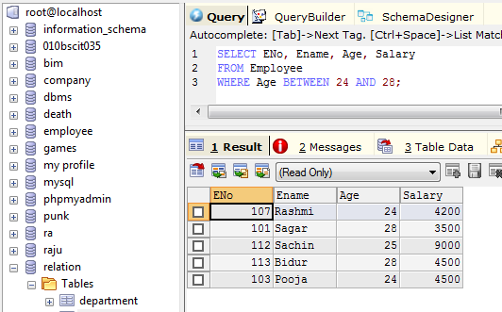

1. String Operations

‘ABC%’- all strings that start with ABC

Example: ABCD and ABCDABCD

‘%XYZ’ – all strings that end with XYZ

Example: WXYZ and ZZXYZ

‘%AN%’ – all strings that contain the pattern AN anywhere

Example: LOS ANGELES and SAN FRANCISCO

Find Eno, Ename whose starting letter is ‘sa’

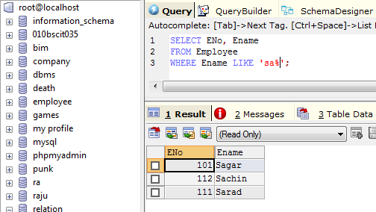

1. List all employee names with their project names

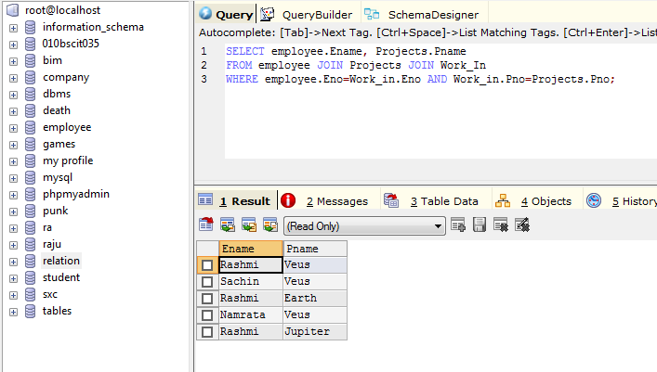

1. List name of all employee and their salary who are working in project mars or venus.
2. List name of all employee and their salary who are working in project earth and venus.
3. List name and address of all employee who works in department which is located in Pokhara.